**Assignment 1: Bitcoin Mainchain Applications**

* Write a bash program that retrieves the last 100 blocks in the main chain using APIs from <https://www.blockcypher.com/dev/bitcoin/#blockchain-api> and saves them to local directory.

* Relevant fields to store and print are hash, height, total, time, relayed_by, prev_block

* Write 4 C programs(binaries) that read the data and perform the following:
  1. Print the saved blockchain:

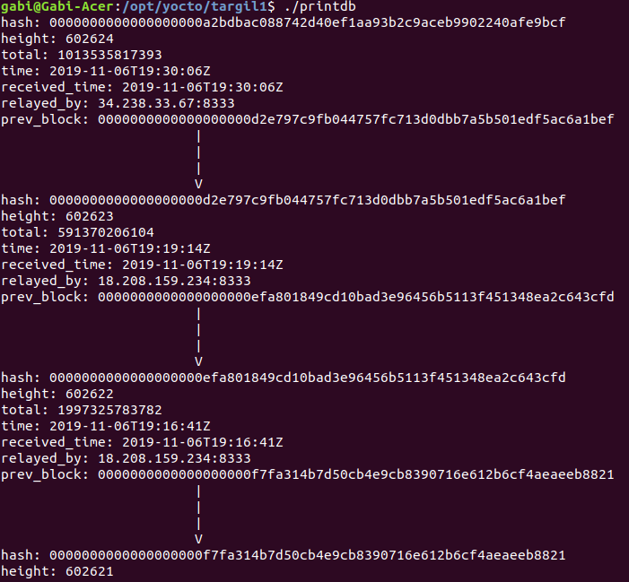

* 1. Print certain block by
     1. Hash

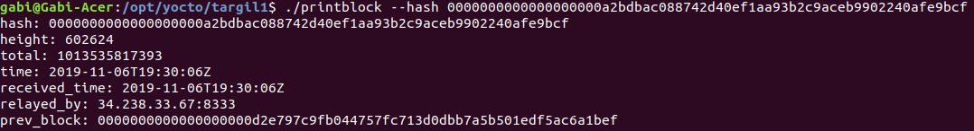

* + 1. Height(id)

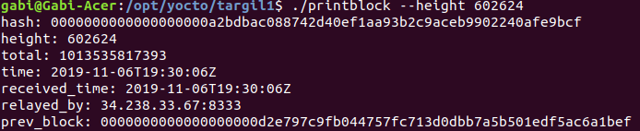

* 1. Export data to CSV



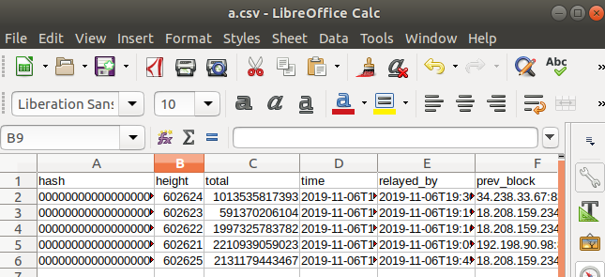

* 1. Reload the database (rerun the bash script)
* Write a utility library that provides functionalities like load_db, print_blocks, etc... and compiled as shared library(.so) and used by all first 3 programs
* Write a makefile that compiles all C programs (4 binaries and the shared library)

**How to submit?**

Zip all files together (only source files(.c, .h, .sh, Makfile), no binaries/output files(.o, .out, .so, etc...)).

I will unzip your zip file and then:

1) run the bash script and inspect the files it retrieved

2) Run “make” and make sure there are 4 .out programs, and 1 .so

3) Run each of the programs and expect the output described above